NCIA QC Tool Deletion Implementation

Software Design Description

Version 1.0

10/05/2009

Document Change Record
Version Number | Date | Description
1.0 | 10/05/2009 | Initial document

TABLE OF CONTENTS

Software Design Description i
Version 1.0 i
01/27/2009 i
1. Introduction 1
2. System Architecture 2
3. Components 5
4. class diagram 7
5. Sequence diagram 8
Appendix A – acronym List 10

Introduction
The purpose of this implementation is to provide a deletion tool or a deletion function to the NBIA application. This function allows users to remove one or more series in a study for a patient. The function will categorize as two processes, mark one or more series as a to-be-deleted and removes marked records from database; all related DICOM image files will be removed as well in hard delete.

A CRON job will be created for off-line deletion. However, there is an exception. If the second layer deletion needs to be executed immediately, QC tool deletion also will provide a function to do on-line deletion.

In order to implement deletion functions in current QC tool, it is necessary to change existing QC tool structure.

The existing QC tool has three choices for image status,
- Not Yet Review
- Not Visible
- Visible

The new status for QC tool deletion will be added,
- To Be Deleted
- Deleted

Main focus in this design document is how to physically remove records and files from a CRON job or from on-line deletion.

From QC tool, users can mark one or more series status as “deleted”. When deletion is invoked by the CRON job, it will search all records that are marked as “deleted” in series table, and delete all related CT images, images, or studies, or patients from database. In addition, the all images related DICOM file and JPEG files are also will be removed from the file system. During deletion, physical deletion will also record audit trail in the NBIA database for each record.

How the application decides when removing a study or a patient during series records deletion? The rule is simple, after removing records from series table, check the study if more series exist. If there is no, it means this study doesn’t have any series attached to it. Then this study can be removed. If there are more series still attached to this study, application will keep this study. The same rule applies to patients.

System Architecture
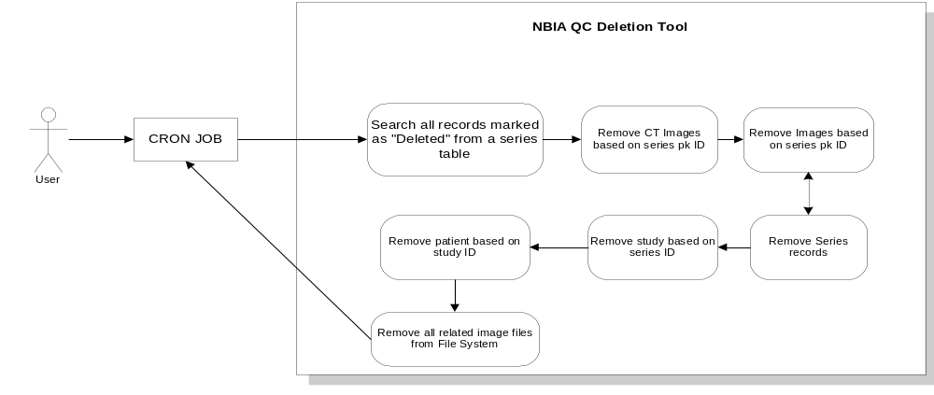
Figure 1: QC Tool deletion through CRON job
Figure 1 indicates how users invoke a CRON job to perform QC tool deletion. QC tool deletion searches all records that are marked as “deleted” from series table. Based on these series IDs, it will remove all records from CT image table, General Image table. Then also from series table, it will obtain study PK ids which these series belong to. Check if deleted series ids are only series for this study. If they are, remove this study also. If these studies have been removed, application also checks the patient which these studies belong to. If there is no study left after removing, this patient will be deleted too.
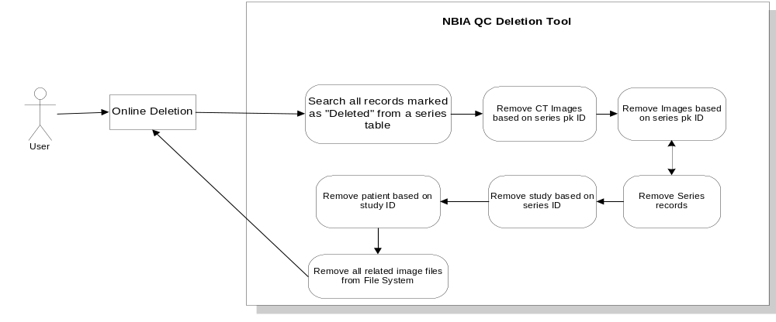
Figure 2: Performing Online Deletion
Figure 2 indicates online deletion. The process is exact like CRON job deletion. Only difference is Online deletion happens as the users click on “online delete” button.GUI will not also show this button to the user, unless this user has the “online delete” permission/authorization.

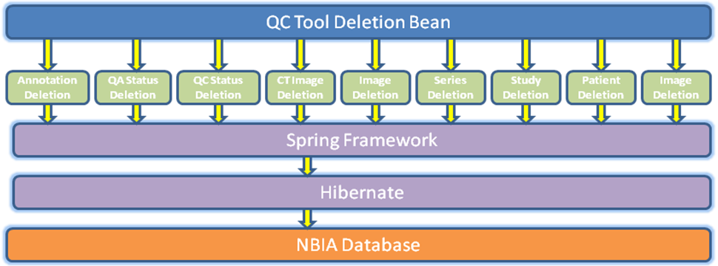
Figure 3: High level Design Structure
Figure 3 is the high level design structure for QC Tool deletion implementation. When NCIA application service receives a deletion request from browser, the request will be forwarded to QC Tool Deletion Bean. QC Tool Deletion bean will check will-be-deleted records from general series table and then find all series PK ID for them. QC Tool deletion will start from Annotation deletion, then QA status deletion, QC Status deletion, CT image deletion, Image deletion, series deletion, study deletion, patient deletion, and DICOM image file deletion.

Online deletion GUI
There will be a GUI for super user to perform online deletion. It will display all series Instance UIDs that will be removed. Also, if he/she is a super user, there will be a link (online deletion) shows up on left side menu.
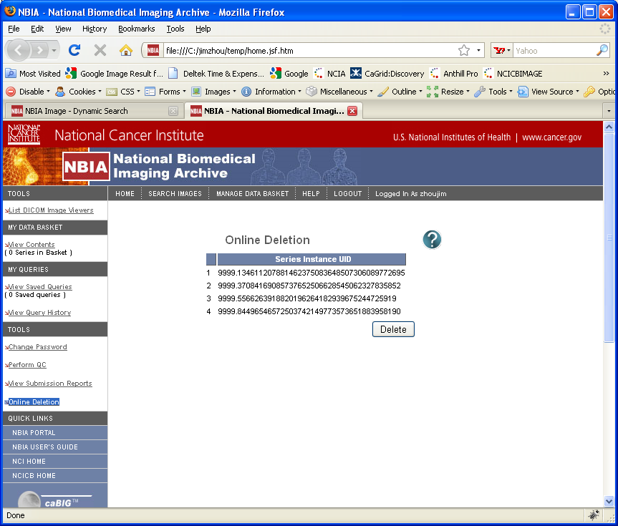

How to set up super user account,
In CSM, we will create a super user role, and also give a PG named “online_deletion” with no PE. The link “online Deletion” will be displayed based on this role.

components
- NBIA Deletion Bean Class
This is the main class for QC Tool Deletion application. It will initialize QC tool deletion process and perform all necessary deletions, such as annotation deletion, QA status history deletion, QC status history deletion, CT image deletion, general image deletion, general series deletion, study deletion and patient deletion, at last, it also will delete physical image file from NBIA File System.
During the initialization, NBIA Deletion Bean first will find out which series will be removed based on status from general series table.

- Annotation Deletion Class
Annotation Deletion Class will remove all annotation records based on series PK id passed in from NBIA Deletion Bean Class.

- QA Status History Deletion Class
QA Status History Deletion Class is to remove all series related status records from QAStatusHistory table. This is class is really for legacy data because after implementing a new QC Tool, QA Status History table will be replaced by QC Status History table.

- QC Status History Deletion Class
This class will delete all series related QC status records. In QC status table, we are using series Instance UID as foreign key to connect to series table. Before the deletion occurs, we need to get all series instance UID correspond to series PK id. Then we can perform deletion based on series instance UID.

- CT Image Deletion Class
This class will remove all CT image records that are related to deleted series records. In order to delete these records, this class also has a method to find out all general images’ PK id by giving series PK id.

- General Image Deletion Class
This class will remove all general image records that are related to deleted series records. In order to do this, we need to find out all image ids based on list of series IDs. Inside this class, there is a method to perform this function.

- General Series Deletion Class
This is class will remove general series records based on the giving series pk ID.

- Study Deletion Class
Before this class performs deletion process, it will check the study if it needs to be removed or not. Therefore, this class has a method to check series. If there is no result comes back by giving a study PK id, this study is the candidate to be deleted.

- Patient Deletion Class
This class will be invoked if the study deletion occurs. Still, before performing patient deletion, this class needs to check if this patient contains no study except the one that will be removed soon.

- Image File Deletion
If there is any image record removed from general image table, this deletion will occurs to remove all image related DICOM files from NBIA File System.

- Deletion Audit Trail
This class will record deletion information for Series, Study and Patient. The information will include,
- Data ID
This ID could be series Instance UID, Study Instance UID or Patient ID depends on what kind of data type.
- Data Type
When deleting general series, study or patient, Data Type will be “General Series”, “Study”, or “Patient”
- Total Images
When deleting general series, the total images will be total number of images that this series contains. Otherwise, this field will be null.
- User Name
When deleting general series, deletion administrator’s user name will store in this field. When a CRON job perform deletion, “System” will be put into this field.
- Time Stamp
This field will record the time when deletion occurs. The formation of this time will be “MM/DD/YYYY hour:minute:second”.

SQL statement to create this table:

CREATE TABLE `deletion_audit_trail` (
`deletion_pk_id` bigint(20) NOT NULL,
`data_id` varchar(64) default NULL,
`data_type` varchar(50) default NULL,
`total_image` bigint(20) default NULL,
`user_name` varchar(50) default NULL,
`time_stamp` datetime default NULL,
PRIMARY KEY (`deletion_pk_id`)
) ENGINE=InnoDB DEFAULT CHARSET=latin1

Additional Components:

- Spring Framework Layer
Sprint Framework Layer is to control transaction. By using it, we can easily define a set process in one transaction. If there is one failure, whole processes will roll back. Therefore, we can maintain data integrity.

- DB Adapter (CTP)
New QC Tool will be redesign to fit in latest QC Tool GUI. All visibilities will be based on general series’ visibilities. DB adapter codes need to be changed coordinately. We will remove all insertions of visible status for patient, study, general image, and CT Image tables.

- Online Deletion Class
The quartz job is going to call this method to start online deletion. The process is similar to NBIA Deletion Bean class. It deleted records starting from annotation, QA status history, QC status history, all the ways to patient and physical DICOM image file deletion.

Class diagram
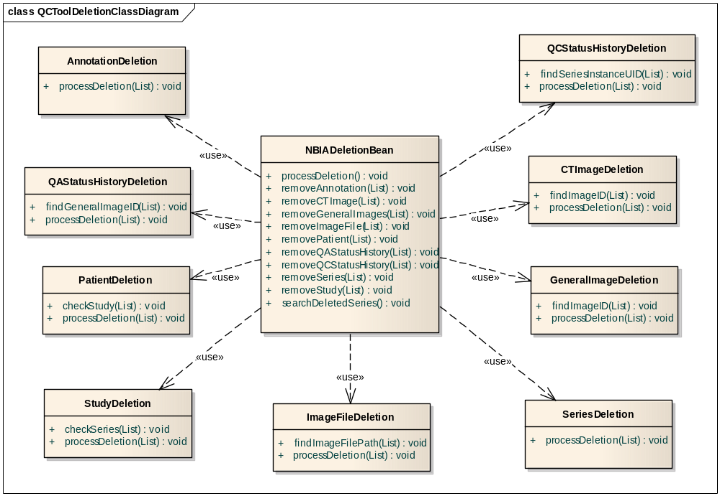
Figure 3: QC Tool Deletion Class Diagram
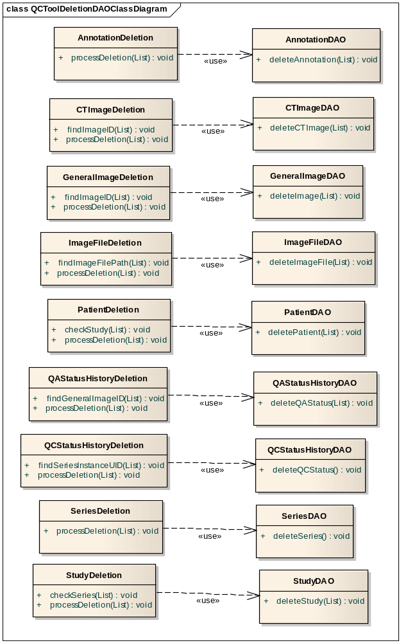
Figure 3: QC Tool Deletion Class Diagram

In above diagrams, they indicate all class objects will be used in QC Tool Deletion process.
All XXXDeletion classes will be used in middle tier to process deletion. The XXXDAO classes will be backend been to perform actual deletion.

Sequence diagram
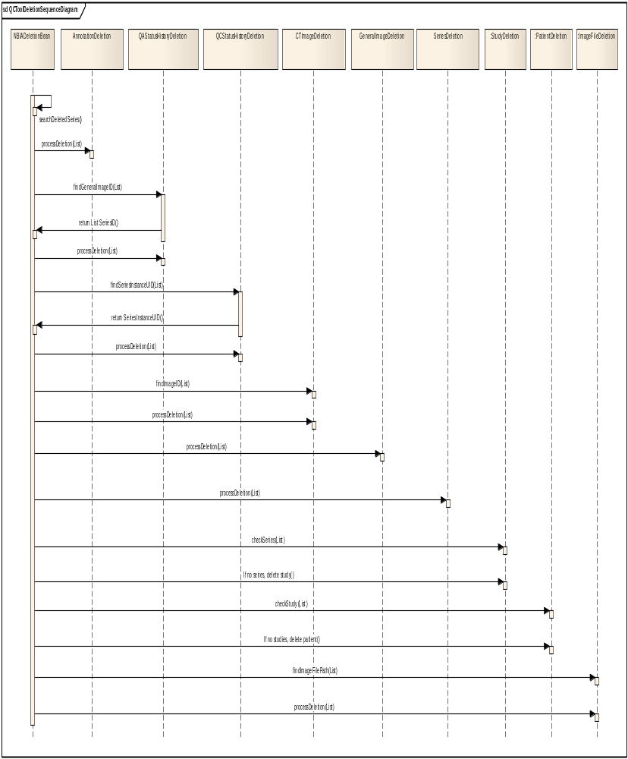
Alternative:
Alternative 1:
When QC Tool Deletion fails, all deleted data will be rolled back. An error message will be in NBIA log file and an email will be sent to this super user.

Alternative 2:
When CTP updates a record, in the same time, online / offline deletion tries to delete this record. The result will be both failed insert/delete this record because database will handle this conflicting transaction. CTP will have a log indicates this failure, and deletion process also will send an error message back to client for this failure. When this happens, CTP data insertion and QC Tool deletion need to be re-processed. He/she needs to make sure these two processes will not be occurred in the same time.

Appendix A – acronym List
[Insert an alphabetical listing of all acronyms, abbreviations, and their meanings as used in this document.]
Acronym | Description
CI | Configuration Item
DBA | Database Administrator
MS | Microsoft
PM | Project Manager
RM | Requirements Manager
RTM | Requirements Traceability Matrix
SCM | Software Configuration Management
SDD | Software Design Description
SDLC | Software Development Lifecycle
SDP | Software Development Plan
SE | Software Engineering
SEPG | Software Engineering Process Group
SPE | Software Product Engineering
SM | Software Manager
SOP | Standard Operating Procedure
SPI | Software Process Improvement
SQA | Software Quality Assurance
SRS | Software Requirement Specification
SW | Software
TM | Test Manager

